Policy Gate (former Ardno Lodge, also known as ‘Maggie Luke’s’)
(Christina Noble’s House)

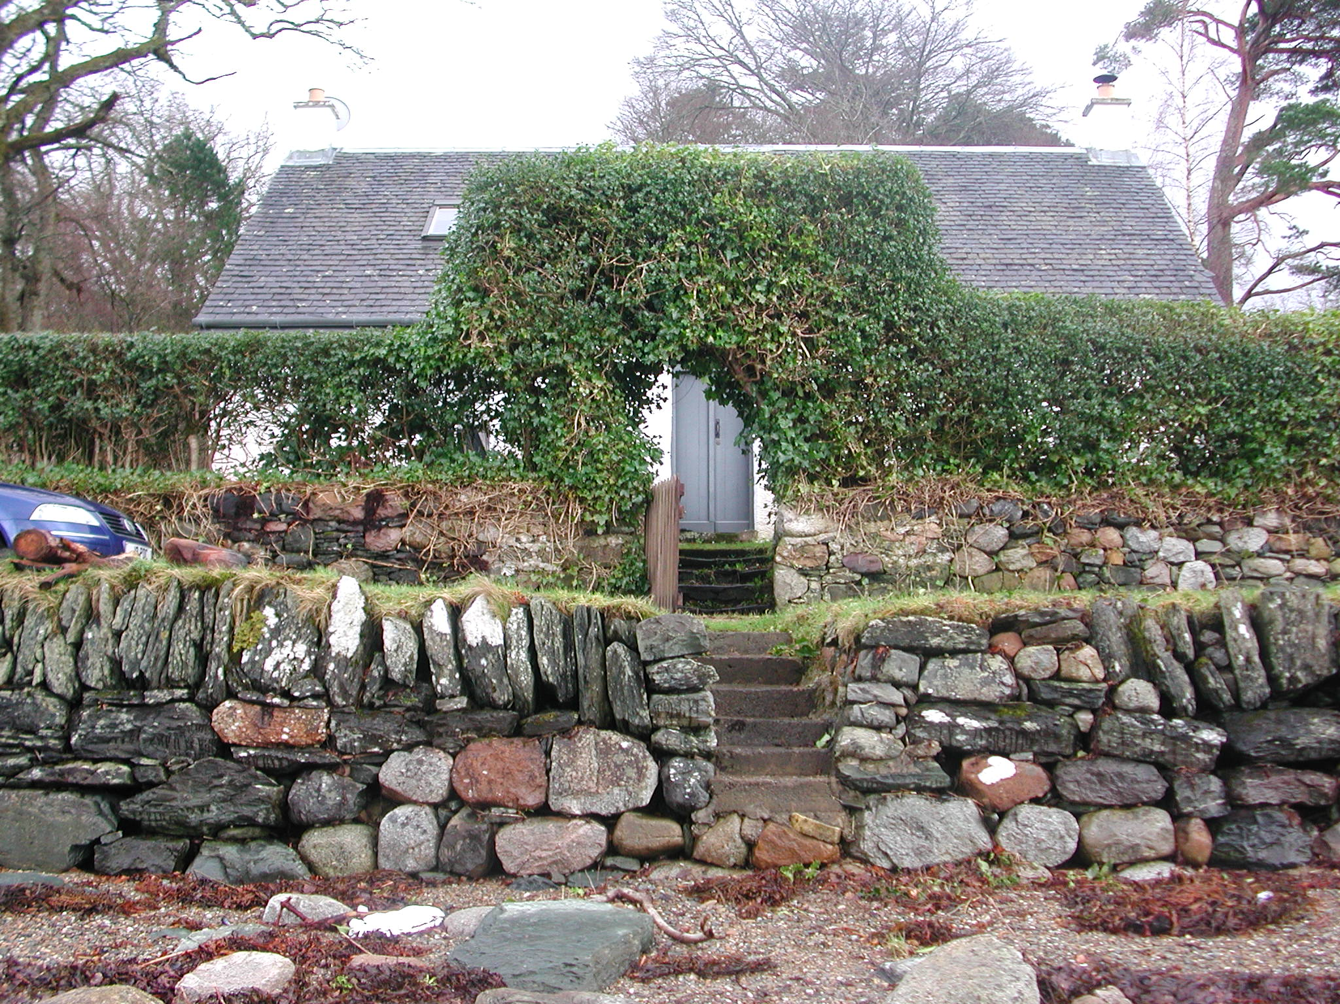

Polity Gate

i. Historical evidence and known architectural history

Policy Gate Lodge appears in the 1841 census and also as a rectangle on the 1st Edition Ordnance Survey. In the Ordnance Survey Name Book of the Parish of Kilmorich, Argyllshire of 1870 it is listed as one of ‘three Lodges’.

Christina Noble possesses a series of photos dating back to 1971 showing the building from various viewpoints, very much as today, bar the rear wing. This shows the cottage very much as it is now with the exception of a former lean to shed, dark in colour and wood in construction, this abutted the eastern half of the rear wall on the south side of the building. Just west of this there was a window. Between the existence of this lean to and the construction of existing rear wing, there was a further lean to structure containing a kitchen.

In the possession of Christina there are a set of plans for a rear extension dated March 1971 by Bernard G.L. Preston, Chartered Surveyor, 61 West Princes St. Helensburgh. They are titled Proposed Improvements to Policy Gate lodge, Ardkinglas, Cairndow for John Noble Esq. They show a flat-roofed rear extension and a continuous dormer occupying the central portion for the rear pitched to the south of the main roof.

The set of plans for the existing rear wing are by Archie Provan, dated March 1985. The rear range is built double-skinned concrete block construction. There are good series of photographs of work in progress in 1985 held by Christina Noble. Built by John MacDonald.

The original rear extension involved the widening of the early opening shown in the rear wall, which may have been a window. The existing rear extension involved slapping a new opening through the rear a little bit further to the E.

ii. General

A well-preserved estate cottage of 1½ storeys with a new extension on the back, making it a T-plan. Both the main range and the rear extension are double pitched and slated, and the entirety of the exterior is harled and painted white. The frontage of the earlier part of the building faces Loch Fyne to the N.

In common with some of the other earlier estate cottages, such as Glashoine, Policy Gate is relatively deep in plan and commodious.

The building is accessed from the shore road running on the N side where there's a stone built boundary wall with a gate within it, stone steps rising up directly opposite the principal entrance.

iii. Exterior

The N frontage is symmetrical - a central entrance with equally spaced windows on either side. The latter are relatively recent though of traditional sash and case form, detailed with plain horns extending down from the upper sash. The eastern window has a raised margin surround of tooled stone, with harl butting up against this; by contrast for the western window the harl has been taken around the arises and there is no margin.

The entrance is accessed by two stone steps and contains an original door and door frame. The door itself is of two opposing leaves and there's an iron latch brass key plate, etc. and it's vertically boarded and there's a bead at the junction of the tongue groove. Above there's a pair of small horizontal lights.

The rear range has a slightly steeper pitched roof and is accessed by external door at the N end of its E wall. Further S in this wall there is a window. In the S gable end there is a projecting squared chimneybreast, a small window on its E side, and in its W wall two individual windows; the windows are all of traditionally detailed sash and case form.

The present livery of the building is white with grey woodwork. In some places on the earlier parts of the building limewash is visible below the later paints, these are multiple layers of white and, later on, an apricot hue.

There are various Allan & Mann : Govan Road : Glasgow bricks lying around the outside and also the heavily worn schist threshold stone of what may have been ?the original back entrance, before the extension.

Interior

The front entrance contains opposed doors of plank and batten construction. Internally there are various pieces of door furniture, box-locks and latches, etc. and stay-bars still in place. The two lights above have a simply chamfered glazing bar profile.

Hall-vestibule

One entered into a small hall-vestibule with a stair entrance directly opposite and further entrances into the ground floor principal rooms on either side. This interior is plain plastered. All of the doors, plasterwork and doorframes are apparently original and in very good condition, an excellent example of this type of architecture. The three entrance architraves are of plain boards affixed onto the frames. The three doors are all of plank and batten construction, those on either side of four battens, the stair door with three. All are tongue-in-groove jointed with narrow beads at the joints. Each of the three doors has a good iron latch; the door to the E has a box lock with bakelite handles and a brass key plate.

E ground floor room

The principal ground floor room to the E is a well-appointed interior. It is lit by the window to the S; this has narrow glazing bars, the window appears to be secondary. There is a fireplace in the centre of the E gable wall this is equally well preserved with cast-iron inset and wooden surround with keystone and mantelshelf above and stone hearth surviving.

To the N of the fireplace there is a press whose wooden shelves remain; this seems likely to have had a door, hinged from the N, that no longer remains. Skirting throughout is of plain pine boarding, walls plastered onto the hard, ceiling plaster seems to have been replaced. Within the internal partition walling to the W there was formed a central recessed area.

The principal feature of the room lies to the S where there survives a very well preserved pair of early box beds. These are simply framed, the timbers employed edged with a narrow bead. The lower part of the bed interiors are plank lined, whereas the upper part are plastered. There are small brass knobs on either side of the bed openings, presumably tie-backs for the hangings in front. There are under-bed spaces.

W ground floor room

The W room is relatively well preserved. The 1971 plans, however, show that much of the S side was occupied by further sub-partitioning. At the SW corner there may have been a further box bed. To the SE there is a door that survives within partitioning which is early; this now provides access to the rear wing, but previously provided access to a cupboard area that occupied the central part of the S side of the W room. This has now been dismantled although some scarring of it can still be seen on walls and ceiling.

The surviving door in the SE corner is original. As elsewhere this is of plank and batten construction (4 battens, tongue-in-groove boarded, with the bead at the junction). Adjacent to this in the E wall is an under-stair area accessed by means of a further plank and batten door, the latter with a brass handle. There is some early shelving surviving along the most of the E wall, close up to the ceiling; this is supported by plain angled brackets of wood.

The W wall of this interior retains a wonderfully preserved range of cast-iron. This has a central grate and water heater on one side and small oven on the other. The swey of wrought iron still remains in situ and the surround, which is of wood, is also original - including central ‘keystone’ and mantelshelf above. The two sash and case windows to N and NW are secondary replacements

Rear extension – ground floor

At ground floor level in the rear extension one enters from the external entrance on the E side into a small entrance vestibule. From within this area a new entrance was broken through into the rear of the early range immediately to the N. Ahead (to the W) is a bathroom with bath and WC, and to the S there is an entrance into the existing kitchen. This substantial room occupies the entirety of the N end of the range; it is lit by large paired windows to E and W, and one in the S wall that is offset to the E. All the windows are all of sash and case construction (two above two panes), the larger windows in the east and west walls have long horizontal panes, all have brass sash lifts. The doors in this area are all of plank and batten construction with v-section tongue-in-groove boarding and generally varnished, though the back of the kitchen door is white. Kitchen units line the W, NW and SW parts of the kitchen; there is a dark blue Raeburn in the centre of the S gable wall.

Upper level

There is a straight flight of stairs up to the first floor. This is lined to either side with wood boarding, the joints sealed with battens. At the head of the stair there is a small vestibule-landing with original entrances off to the E and W into the bedroom interiors. The doors at the entrances have however been replaced but are of traditional plank and batten construction with V-section tongue and groove boarding.

The eastern bedroom interior has seen relatively recent re-lining throughout and retains few early features. There are two velux skylights that are clearly secondary. At least one of these likely replaced an earlier cast iron skylight - this is likely to have been in the rear pitch as the existing velux in the front pitch is relatively recent.

Coming into the western room the principal feature of the interior is the wonderfully preserved pair of box beds along the N wall. These are of unpainted pine construction, simply formed of overlapping boards, nailed. To the W there is a framed-in closet that is very notable for the lining paper within, which appears to be Illustrated London News cuttings; all are dated from the 1890s. This papering may have been a simple draught- or dust-prevention measure to protect clothing within. There are hook battens against the walls and numerous old brass and iron coat hooks. There is a recently constructed walk-in closet recess to the SE that is partly within the roofed area of the 1980s rear extension.

Upper level of rear extension

The rear roof pitch of the original part of the house has been broken through to connect into the new rear extension. Here there is an open access at the head of the stairs. One enters into a large vestibule that is offset to the E. To the W in this area there is a bathroom, and the southern part of the extension is wholly occupied by a substantial bedroom. The bedroom is lit by paired veluxes, one in each pitch, the vestibule and bathroom each by a velux as well. The doors throughout are of varnished pine, plank and batten construction as elsewhere to match. The entirety of the interior is plain plastered - walling, ceiling, etc.

